JAVA RMI
RMI stands for Remote Method Invocation. It is a mechanism that allows an object residing in one system (JVM) to access/invoke an object running on another JVM. RMI is used to build distributed applications; it provides remote communication between Java programs. It is provided in the package java.rmi.
Architecture of an RMI Application
In an RMI application, we write two programs, a server program (resides on the server) and a client program (resides on the client).
- Inside the server program, a remote object is created and reference of that object is made available for the client (using the RMI registry).
- The client program requests the remote objects on the server and tries to invoke its methods.
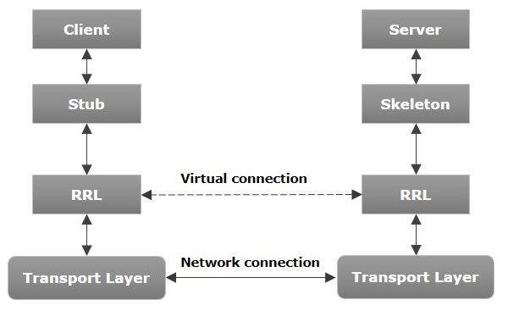
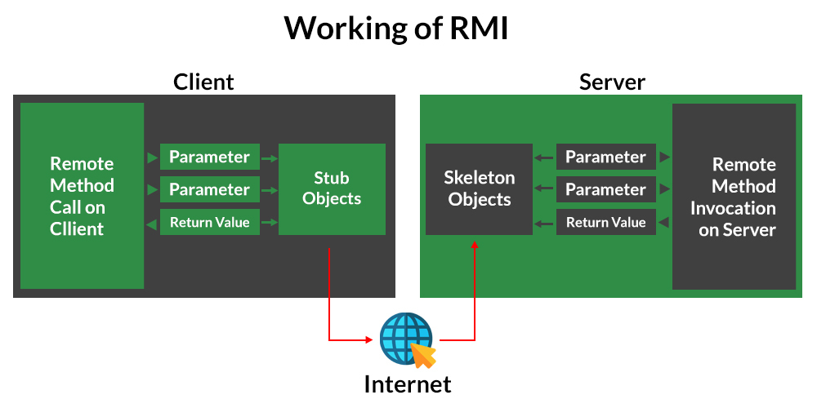
Stub Object: The stub object on the client machine builds an information block and sends this information to the server.
The block consists of
- An identifier of the remote object to be used.
- Method name which is to be invoked
- Parameters to the remote JVM
Skeleton Object: The skeleton object passes the request from the stub object to the remote object. It performs the following tasks.
- It calls the desired method on the real object present on the server.
- It forwards the parameters received from the stub object to the method.

Let us now discuss the components of this architecture.
- Transport Layer − This layer connects the client and the server. It manages the existing connection and sets up new connections.
- Stub − A stub is a representation of the remote object at client. It resides in the client system; it acts as a gateway for the client program.
- Skeleton − This is the object which resides on the server side. stub communicates with this skeleton to pass requests to the remote object.
- RRL (Remote Reference Layer) − It is the layer which manages the references made by the client to the remote object.
Working of an RMI Application
- When the client makes a call to the remote object, it is received by the stub which eventually passes this request to the RRL.
- When the client-side RRL receives the request, it invokes a method called invoke() of the object remoteRef. It passes the request to the RRL on the server side.
- The RRL on the server side passes the request to the Skeleton (proxy on the server) which finally invokes the required object on the server.
- The result is passed all the way back to the client.
Marshalling and Unmarshalling
Whenever a client invokes a method that accepts parameters on a remote object, the parameters are bundled into a message before being sent over the network. These parameters may be of primitive type or objects. In case of primitive type, the parameters are put together, and a header is attached to it. In case the parameters are objects, then they are serialized. This process is known as marshalling.
At the server side, the packed parameters are unbundled and then the required method is invoked. This process is known as unmarshalling.
To write an RMI Java application, you would have to follow the steps given below –
- Define the remote interface
- Develop the implementation class (remote object)
- Develop the server program
- Develop the client program
- Compile the application
- Execute the application

RMI Registry
RMI registry is a namespace on which all server objects are placed. Each time the server creates an object, it registers this object with the RMIregistry (using bind() or reBind() methods). These are registered using a unique name known as bind name. To invoke a remote object, the client needs a reference of that object.
At that time, the client fetches the object from the registry using its bind name (using lookup() method). The following illustration explains the entire process −
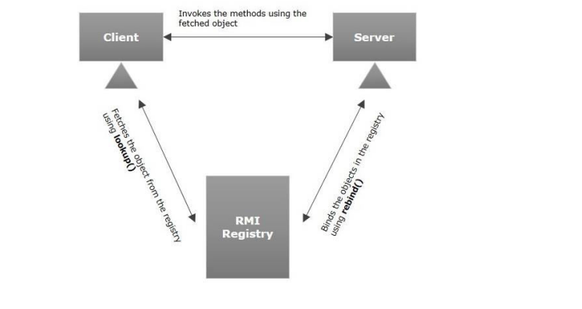
Goal of RMI
- To minimize the complexity of the application.
- To preserve type safety.
- Distributed garbage collection.
- Minimize the difference between working with local and remote objects.

Remote Object Activation:
Automatic activation of remote objects is a new feature in RMI as of Java 1.2.
The activation subsystem in RMI provides you with two basic features: the ability to have remote objects instantiated (activated) on-demand by client requests and the ability for remote object references to remain valid across server crashes, making the references persistent. These features can be quite useful in certain types of distributed applications.
For example, We might not want to keep the AccountManager class running on our server 24 hours a day; perhaps it consumes lots of server resources (memory, database connections, etc.), so we don't want it running unless it is being used. Using the RMI activation service, we can set up the AccountManager class so that it doesn't start running until the first client requests an Account. In addition, after some period of inactivity, we can have the AccountManager shut down to conserve server resources and then reactivated the next time a client asks for an Account.
Developing the Server Program
An RMI server program should implement the remote interface or extend the implementation class. Here, we should create a remote object and bind it to the RMIregistry.
To develop a server program
- Create a client class from where you want to invoke the remote object.
- Create a remote object by instantiating the implementation class as shown below.
- Export the remote object using the method exportObject() of the class named UnicastRemoteObject which belongs to the package java.rmi.server.
- Get the RMI registry using the getRegistry() method of the LocateRegistry class which belongs to the package java.rmi.registry.
- Bind the remote object created to the registry using the bind() method of the class named Registry. To this method, pass a string representing the bind name and the object exported, as parameters.
RMI Example:
- create the remote interface
import java.rmi.*;
public interface Adder extends Remote {
public int add(int x, int y) throws RemoteException;
}
- Create and run the server application(MyServer.Java)
import java.rmi.*;
import java.rmi.registry.LocateRegistry;
import java.rmi.registry.Registry;
import java.rmi.server.UnicastRemoteObject;
public class MyServer extends UnicastRemoteObject implements Adder {
public MyServer() throws RemoteException
{
super();
}
public static void main(String[] args) throws RemoteException
{
try {
Registry reg=LocateRegistry.createRegistry(5000);
reg.rebind("hi_server",new MyServer());
System.out.println("Server is Now Ready..");
}
catch(RemoteException e)
{
System.out.println(e);
}
}

@Override
public int add(int x, int y) throws RemoteException {
return x+y;
}
}
6) Create and run the client application (MyClient.Java)
package com.samriddhi.mavenproject6;
import java.rmi.*;
import java.rmi.registry.Registry;
import java.rmi.registry.LocateRegistry;

public class MyClient {
public static void main(String[] args) throws RemoteException
{
MyClient client=new MyClient();
client.connectRemote();
}
private void connectRemote() throws RemoteException
{
try{
Registry reg=LocateRegistry.getRegistry("localhost",5000);
Adder ad=(Adder)reg.lookup("hi_server");
System.out.println("Addition:"+ad.add(20, 30));

}
catch(NotBoundException|RemoteException e)
{
System.out.println(e);
}
}

}

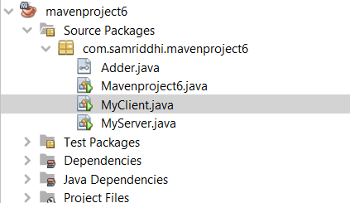

(ServerSide) Output:
Server is Ready..
ClientSide Output:
Addition:50
RMI(Remote Method Invocation) | CORBA (Common Object Request Broker Architecture)
RMI is a Java-specific technology. | CORBA has implementation for many languages.
It uses Java interface for implementation. | It uses Interface Definition Language (IDL) to separate interface from implementation.
RMI objects are garbage collected automatically. | CORBA objects are not garbage collected because it is language independent and some languages like C++ does not support garbage collection.
RMI passes objects by remote reference or by value. | CORBA passes objects by reference.
Java RMI is a server-centric model. | CORBA is a peer-to-peer system.
RMI uses the Java Remote Method Protocol as its underlying remoting protocol. | CORBA use Internet Inter- ORB Protocol as its underlying remoting protocol.
The responsibility of locating an object implementation falls on JVM. | The responsibility of locating an object implementation falls on Object Adapter either Basic Object

